# The Eaglehouse Academy

**Subject: Chemistry Class: 10th**

**Marks: 30 Time: 3hrs**

Section “A” Multiple choice question (MCQs)

**Choose the correct answer for each from the given question: (Marks: 6)**

1. The general formula for Alkyl group is :
2. C**n**H**2n** b. C**n**H**2n+1** c. C**n**H**2n+2**  d. C**n**H**2n-2**
3. Corrosive effects on effects on skin is caused by:
4. Acid b. base c. salt d. all of these
5. Fresh water is present on the surface of earth:
6. 0.3% b. 3% c. 0.2% d. 2%
7. Lactose is :
8. Grape sugar b. milk sugar c. honey sugar d. cane sugar
9. If PH value is greater than 7, then solution will be:
10. Acidic b. basic c. Neutral d. Amphoteric
11. Vital force theory was introduced by:
12. Berzelius b. Wohler c. Lewis d. Robert Boyle
13. Water accounts for the weight of a human body is about:
14. 50% b. 60% c. 70% d. 80%
15. The deficiency of vitamin D causes:
16. Beriberi b. Rickets c. Scurvy d. Hemorrhage
17. CH3 – CH2- is ------------- radical
18. Methyl b. Ethyl c. Propyl d. Butyl
19. The functional group –COOH is used for:
20. Alcohol b. Aldehyde c. Carboxylic acid d. Phenol
21. The system is stable in equilibrium when:
22. Qc = Kc b. Qc greater Kc c. Qc less Kc d. None of these
23. Salt among following is:
24. KCl b. KCl c. HNO3 d. None of these

Section “B” (Short Answer Question) Marks: 12

**Note: Answer any eight question from this section. Each question carries 1.5 marks.**

1. What is the atmosphere? List its five major layers.
2. What are the limitation of Arrhenius,s theory?
3. Write three uses of salts?
4. Identify the functional groups is the following compounds
5. CH3-CHO b. CH3-CH2-OH c. C3H7-COOH
6. A solution of HCL has PH of **2.3**. calculate its pOH and [ H**+** ]
7. The value of Kc for the reaction is **1× 10 -4**

**2HI H2 (g) + I2 (g)**

At a given temperature, the molar concentration of reaction mixture is,

**HI = 2 × 10 -5 mol.dm3, H2 = 1 × 10 -5 mol.dm3 and I2 = 1 × 10 -5 mol.dm3.** Predict the direction of the reaction.

1. Write down three characteristics of organic chemistry?
2. Distinguish between reversible and irreversible reaction?
3. The hydrogen ion concentration [H+] is **1 × 10-8 mol.dm3**. What is PH of the solution?
4. Write any three significant uses of carbohydrate?
5. How can we remove temporary hardness of water by clarks method?
6. Write down the molecular , structural and condensed formulae of the following compounds.

|  |  |  |  |
| --- | --- | --- | --- |
| Compounds | Molecular formula | Structural formula | Condensed formula |
| Methane |  |  |  |
| Ethane |  |  |  |
| Propane |  |  |  |

Section “C” (Detailed - Answer Question) Marks: 12

**Note: Answer any four questions from this section. Each carries 3 marks.**

1. State the law of mass action, apply it on the following reversible reaction.and derive the expression for equilibrium constant?

**aA + bB → cC + dD**

1. Distinguish between saturated and unsaturated hydrocarbons?
2. What are lipids? Write five difference between fats and oils?
3. What is ozone? How does ozone depletion occurs by chlorofluorocarbons (CFCs) also mention some adverse impact of it?
4. Describe salts, preparation of salts and types of salts?
5. Distinguish between fat soluble and water soluble vitamin?

The Eaglehouse Academy

**Subject: Biology Class: 10th**

**Marks: 30 Time: 3hrs**

Section “A” Multiple choice question (MCQs)

**Choose the correct answer for each from the given question: (Marks: 6)**

1. The respiratory surface of human is:
2. Nostril b. Bronchiole c. Alveoli d. Trachea
3. Stimulus is detected by:
4. Receptor b. Effector c. Nerves d. all of these
5. The framework which gives shape to any structure is:
6. Bone b. Skeleton c. Cartilage d. Architecture
7. Softening and weakening of bone in children due to deficiency of vitamin D, is called:

a.osteoporesis b. rickets c. Osteoarthritis d. Rheumatic fever

1. The way of seed production without fusion of male and female gametes is called:
2. Scion b. Parthenocarpy c. Apomixes d. Grafting
3. The network of blood capillaries presents in this layer of skin:
4. Epidermis b. Dermis c. Hypo-dermis d. Endodermis
5. The muscle which is responsible to straight the limb:
6. Ligament b. Skeleton muscle c. Flexor d. Extensor
7. The biological function which perform gaseous exchange:
8. Photosynthesis b. Growth c. Respiration d. All of these
9. The shortest path of reflex action consists of:

a.1 neuron b. 2 neuron c. 3 neuron d. 4 neuron

1. The hormone ADH release from:

a.Pituitary gland b. Kidneys c. Liver d. Lungs

1. “ Kitab ul Manazir” was written by:
2. Jabir Bin Hayan b. Ali Ibn Isa c. Bu Ali Sina d. Ibn al Haitham
3. Disorder which is associated with degeneration of Alveoli is:
4. Bronchitis b. Lung cancer c. Emphysema d. Asthma

Section “B” (Short Answer Question) Marks: 12

**Note: Answer any eight question from this section. Each question carries 1.5 marks.**

1. Write down three functions of skeleton?
2. What are xerophytes plants?
3. Write three differences between bone and cartilage?
4. How is rickets? Write its causes.
5. Why is skin considered as excretory organ?
6. Write three differences between chemical and nervous co-ordination?
7. Draw a neat and labelled diagram of ovule?
8. How is the asthma patient characterized?
9. Distinguish between sexual and asexual reproduction?
10. State three differences between Inspiration and Expiration?
11. Explain the structure of neuron?
12. Draw a labelled diagram of Ear?

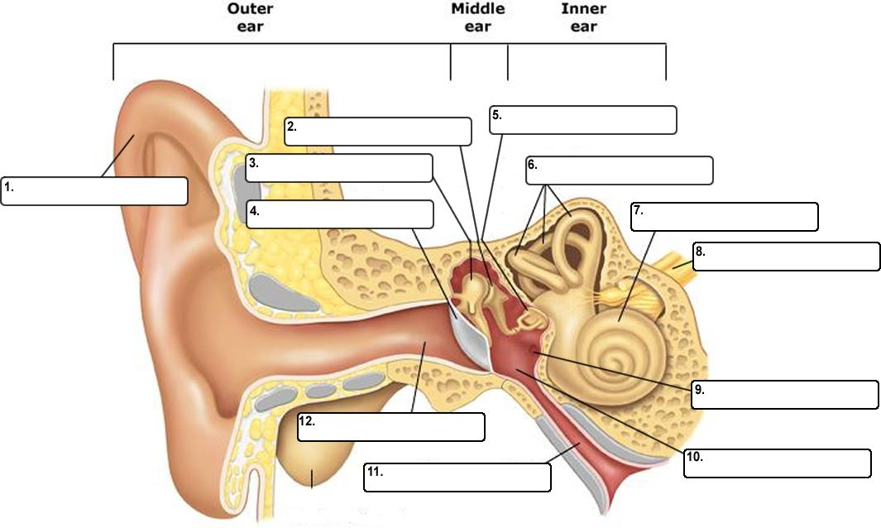

Section “C” (Detailed - Answer Question) Marks: 12

**Note: Answer any four questions from this section. Each carries 3 marks.**

1. What is meant by sexual and asexual reproduction? Describes any five differences.
2. Write down names of disorders of kidney. Explain any two from them.
3. Describe the structure and functions of human Eye or Ear?
4. Describe the urinary system of man with the help of diagram?
5. Describe the structure of human brain?
6. What is diabetes mellitus? Explain some ways of its management?

The Eaglehouse Academy

**Subject: Physics**  **Class: 10th**

**Marks: 30**  **Time: 3hrs**

Section “A” Multiple choice question (MCQs)

**Choose the correct answer for each from the given question: (Marks: 6)**

1. S.I unit of EMF is:
2. ampere b. coulomb c. volt d. watt
3. Branch of physics which deals with the charges at rest is called:
4. Electricity b. Electrostatics c. Magnetism d. Quantum
5. These types of waves cannot travel through a vacuum:
6. Sound waves b. infrared waves c. Microwaves d. X-rays
7. The colour that least deviated by a prism is:
8. Yellow b. red c.green d. violet
9. The main source of energy in the stars is:
10. Chemical reaction b. nuclear fission c. nuclear fusion d. mechanical energy
11. The electromagnetic rays used in radiotherapy to destroy cancer cells are:
12. Infrared rays b. visible rays c. X-rays d. ultraviolet rays
13. In an electric circuit an ammeter is always connected in:
14. Series b. parallel c. mixed d. none of these
15. Magnetic lines of force can easily pass through:
16. Iron b. Air c. water d. wood
17. The condition when the resistance of a circuit is zero is know as:
18. Closed-circuit b. open circuit c. short circuit d. zero circuit
19. It is a software:
20. Hard disk b. monitor c. program d. CPU
21. Three resistances of 3Ω are connected in parallel, their equivalent resistance will be;
22. 1/2 b. 1Ω c. 3Ω d. 9Ω
23. Infra sound can be heard by:
24. Cat b. Bat c. Elephant d. Human

Section “B” (Short Answer Question) Marks: 12

**Note: Answer any eight question from this section. Each question carries 1.5 marks.**

1. Write down three characteristics of electromagnetic waves?
2. Calculate the frequency of radio waves of **3m** wavelength used in an MRI unit?
3. **9J** of heat is produced each second in a **4Ω** resistance. Find the potential difference across the resistor?
4. Write down three differences between Sound and Noise?
5. How much voltage will be dropped across a **50KΩ** resistance whose current is **300µA**?
6. Calculate the speed of sound in air at **30℃**. Given that speed of sound at **0℃ is 331ms-1**?
7. Derive the equation:

**1/Ce = 1/C1 + 1/C2 + 1/C3**

1. Two point charges **q1 = 5µc and q2 = 3µc** are placed at a distance of **5cm**. What will be the coulomb force between them?
2. What is the frequency of **193nm** ultraviolet radiation used in laser eye surgery?
3. Define the wavefront?
4. Define the term transverse wave?
5. Calculate the force acting on a charge of **3µc**, when the electric field intensity is **5N/C?**

Section “C” (Detailed - Answer Question) Marks: 12

**Note: Answer any four questions from this section. Each carries 3 marks.**

1. With the help of circuit diagram derive the formula for equivalent resistance of parallel combination of circuit. Also write three advantages of series combination?
2. State Coulomb,s law and derive the equation:

F= $\frac{1}{4πε}$ $\frac{q1 q2}{r2}$

1. What is simple harmonic motion? Prove that the motion of a simple pendulum is simple harmonic motion.
2. State and explain Ohm,s law also write any three limitation of this law?
3. What is an electric power? Derive and explain power dissipation in a resistor

(derive **P = $\frac{V2}{R}$** )

1. (a) what is the main sources of radio waves?

(b) what is the main advantage of using radio waves in communication?